Module 07 – Maximal Flow

**Exploratory Data Analysis**

Cherry Jubilee Junction

Coconut Cream Cove

Fruity Gusher Geyser

Hazelnut Haven

Marzipan Metropolis

Taffy Tundra

Tartberry Thicket

Vanilla Valley

157

155

89

156

84

104

157

464

157

478

72

101

+0

+0

+0

+0

+0

+0

+0

+0

155

9999

**Model Formulation**

Decision Variables

Let 𝑋𝑖𝑗 represent the units of molten chocolate flow from location 𝑖 to location 𝑗.

Objective Function

Maximize the total molten chocolate reaching Vanilla Valley (Node 7):

max𝑋07

​Constraints (Flow Conservation at Each Node)

Each node follows the flow conservation rule:

0

Flow Constraints for Each Node:

𝑋01+𝑋02+𝑋03=417

Model Optimized for Maximal Flow

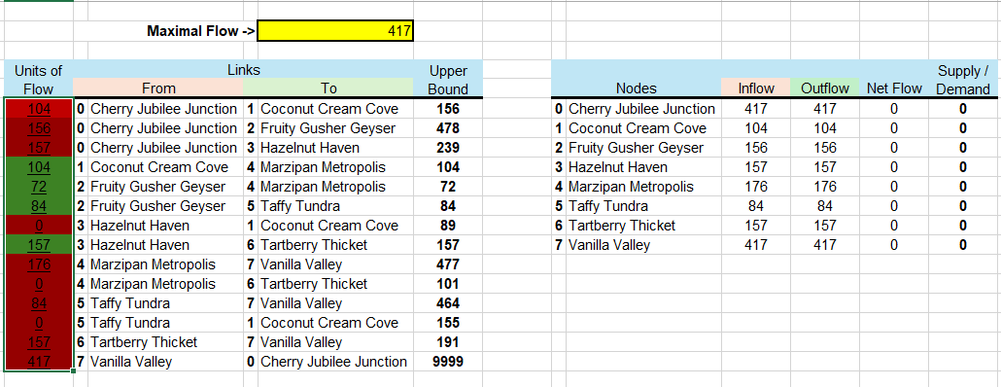

The model optimizes the flow of molten chocolate from Cherry Jubilee Junction (Node 0) to Vanilla Valley (Node 7) while ensuring that no path exceeds its maximum capacity, achieving a total flow of 417 units. However, some paths are operating at full capacity, acting as bottlenecks that restrict additional flow.